**DAILY ONLINE ACTIVITIES SUMMARY**

|  |  |  |  |  |  |  |  |  |
| --- | --- | --- | --- | --- | --- | --- | --- | --- |
| **Date:** | **08/06/2020** | | | | | **Name:** | **Katira Krishna J** | |
| **Sem & Sec** | **8th A** | | | | | **USN:** | **4AL16CS045** | |
| **Online Test Summary** | | | | | | | | |
| **Subject** | | **SMS** | | | | | | |
| **Max. Marks** | | **60** | | **Score** | | | **60** | |
| **Certification Course Summary** | | | | | | | | |
| **Course** | **Hadoop101** | | | | | | | |
| **Certificate Provider** | | | **Cognitiveclass.ai** | | **Duration** | | | **5 hours** |
| **Coding Challenges** | | | | | | | | |
| **Problem Statement: Python program to merge two lists and then sort it** | | | | | | | | |
| **Status: Completed** | | | | | | | | |
| **Uploaded the report in Github** | | | | | **yes** | | | |
| **If yes Repository name** | | | | | **Krishna_Katira** | | | |
| **Uploaded the report in slack** | | | | | **yes** | | | |

Online Test Details:

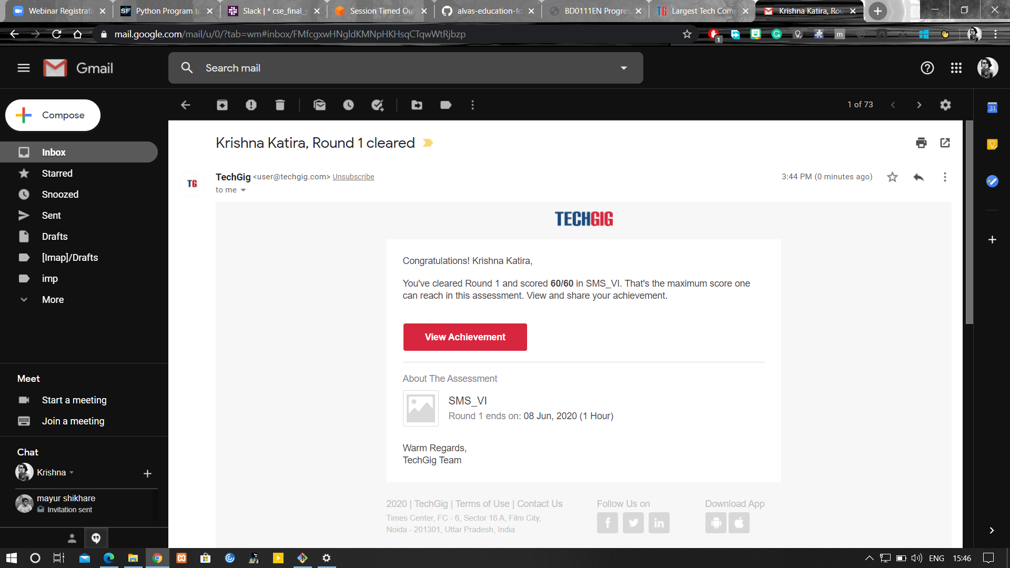

Certification Course Details:

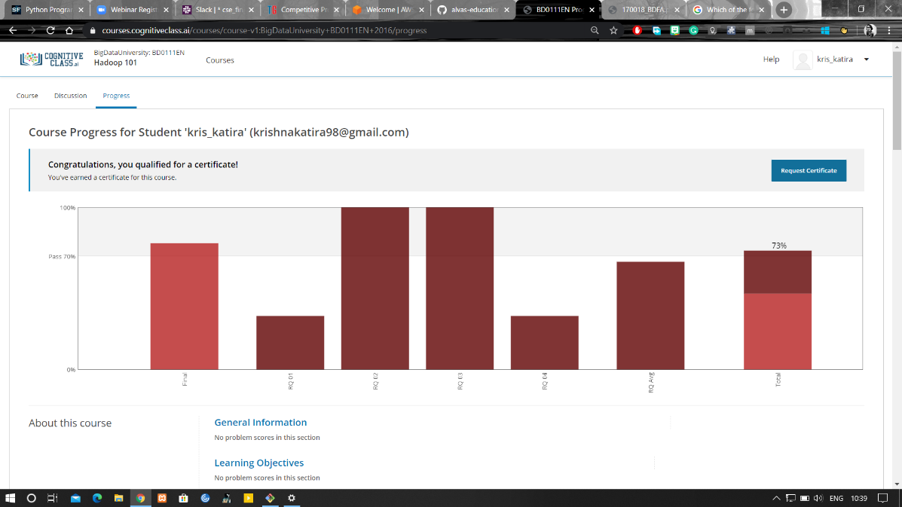

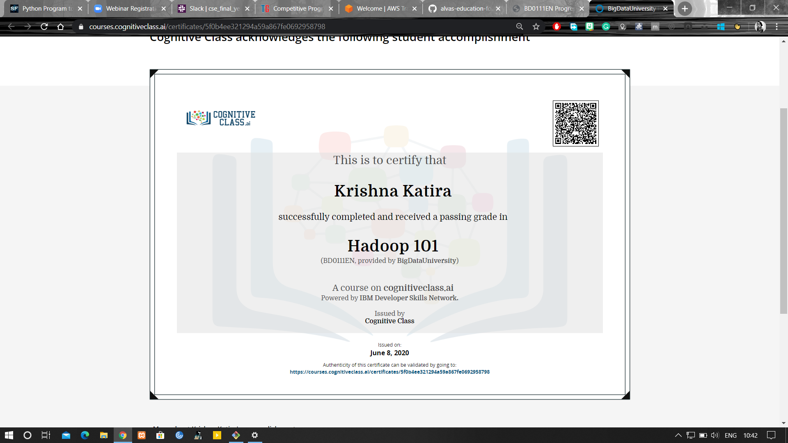

Coding Challenges Details:

**program1**

a=[]

c=[]

n1=int(input("Enter number of elements:"))

for i in range(1,n1+1):

b=int(input("Enter element:"))

a.append(b)

n2=int(input("Enter number of elements:"))

for i in range(1,n2+1):

d=int(input("Enter element:"))

c.append(d)

new=a+c

new.sort()

print("Sorted list is:",new)